Advanced RDDs:
Key-Value RDD Transformations:
groupByKey([numPartitions]):
When called on a RDD of (K, V) pairs, returns new RDD of (K, Iterable<V>) pairs.
Example:
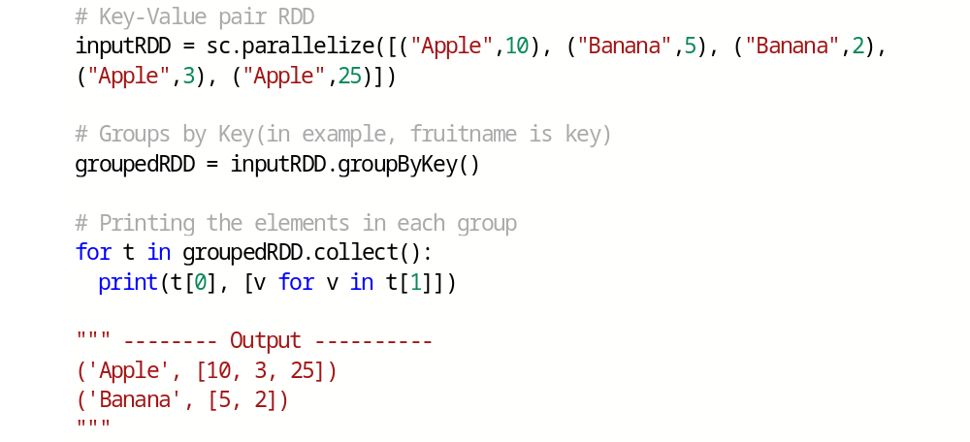
Note:
If you are grouping in order to perform an aggregation (such as a sum or average) over each key, using reduceByKey or aggregateByKey will yield much better performance.

reduceByKey(func, [numPartitions])
When called on a dataset of (K, V) pairs, returns a dataset of (K, V) pairs where the values for each key are aggregated using the given reduce function func.
Function ‘func’ must be of type (V, V) => V (i.e, input parameter datatype and aggregated value datatype should be same)
Example:
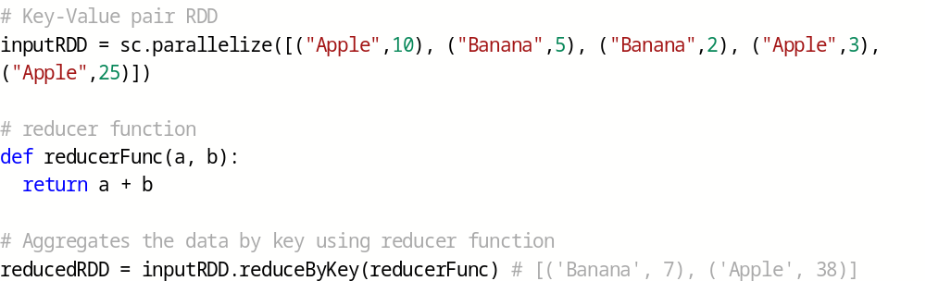

Question: Why reduceByKey() is preferred over groupByKey() for data aggregations?
aggregateByKey(zeroValue)(seqOp, combOp, [numPartitions]):
When called on a dataset of (K, V) pairs, returns a dataset of (K, U) pairs where the values for each key are aggregated using the given combine functions and a neutral "zero" value.
Aggregated value datatype can be different that the input datatype.
seqOp – Sequence operation function which aggregates the values within the partition.
combOp – Combination operation function which aggregates the values across the partitions.(i.e. to output of seqOp function)
zeroValue (or) initial value –
- It can be 0 if aggregation is type of sum of all values
- Or we can also have an empty List or Map object, if we just want a respective collection as an output for each key
Example:

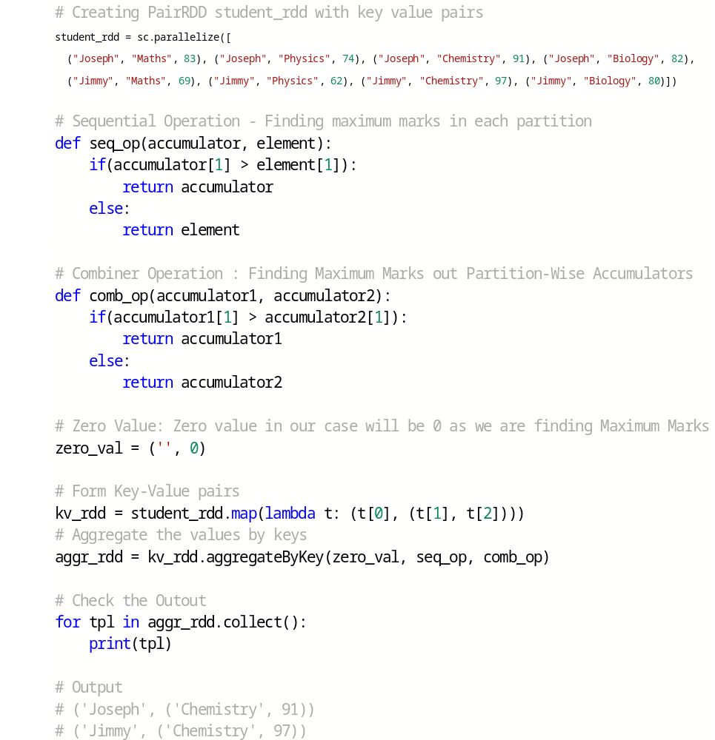

sortByKey([ascending], [numPartitions]):
Sorts by keys in ascending or descending order.
Example: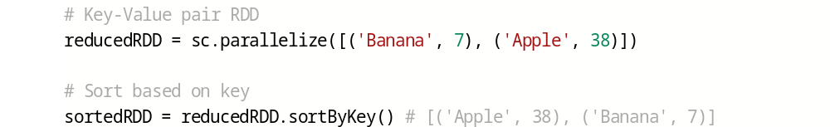
join(otherDataset, [numPartitions]):
When called on datasets of type (K, V) and (K, W), returns a dataset of (K, (V, W)) pairs with all pairs of elements for each key.
Example:
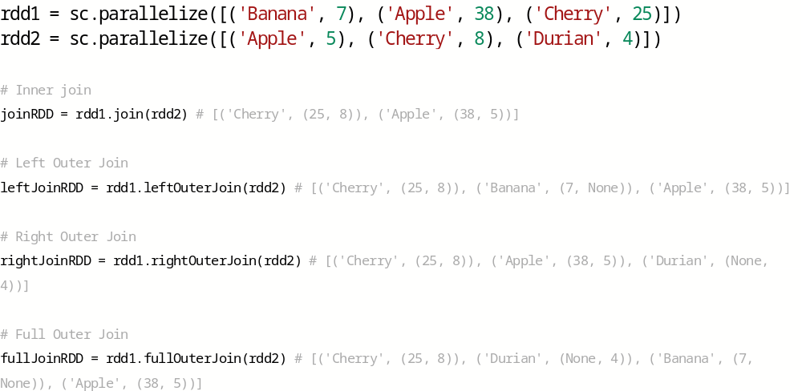

cogroup(otherDataset, [numPartitions]):
When called on datasets of type (K, V) and (K, W), returns a dataset of (K, (Iterable<V>, Iterable<W>)) tuples. This operation is also called groupWith.
Example:

RDD Caching:
- RDDs can be stored in memory/disk using persist()/cache() method.
- cache() method is a shorthand for using the default storage level i.e. StorageLevel.MEMORY_ONLY.
- When you persist an RDD, each node stores any partitions of it that it computes in memory and reuses them in other actions.
- Spark’s cache is fault-tolerant – if any partition of an RDD is lost, it will automatically be recomputed using the transformations that originally created it.
- Caching is a key tool for iterative algorithms and fast interactive use.

Storage Level | Meaning
MEMORY_ONLY | Store RDD as deserialized Java objects in the JVM. If the RDD does not fit in memory, some partitions will not be cached and will be recomputed on the fly each time they're needed.  This is the default level.
MEMORY_AND_DISK | Store RDD as deserialized Java objects in the JVM. If the RDD does not fit in memory, store the partitions that don't fit on disk, and read them from there when they're needed.
MEMORY_ONLY_SER  (Java and Scala) | Store RDD as serialized Java objects (one byte array per partition). This is generally more space-efficient than deserialized objects, especially when using a fast serializer, but more CPU-intensive to read.
MEMORY_AND_DISK_SER  (Java and Scala) | Similar to MEMORY_ONLY_SER, but spill partitions that don't fit in memory to disk instead of recomputing them on the fly each time they're needed.
DISK_ONLY | Store the RDD partitions only on disk.
MEMORY_ONLY_2, MEMORY_AND_DISK_2, etc. | Same as the levels above, but replicate each partition on two cluster nodes.

Checkpointing:
- Checkpointing is a process of truncating RDD lineage graph and saving RDD data to a reliable distributed (HDFS) or local file system.

- Before checkpointing is used, a Spark developer has to set the checkpoint directory using SparkContext.setCheckpointDir(directory: String) method.
- The RDD will be saved to a file inside the checkpoint directory and all references to its parent RDDs will be removed.
Example:

Controlling Partitions:
coalesce(numPartitions):
Decrease the number of partitions in the RDD to numPartitions. Useful for running operations more efficiently after filtering down a large dataset.
Example:
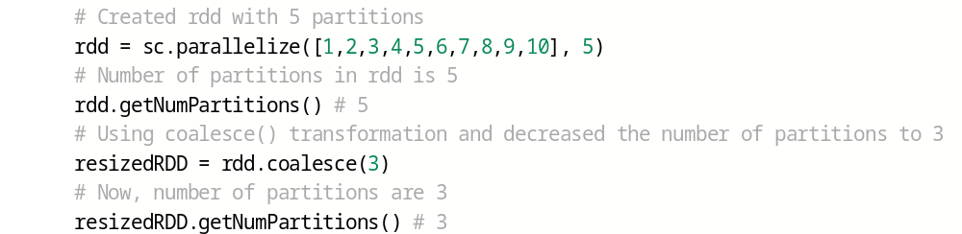
Even if you use specify numPartitions as 20, new RDD will have only 5 partitions. Because coalesce() transformation only decreases the number of partitions.
Example:

repartition(numPartitions):
Reshuffle the data in the RDD randomly to create either more or fewer partitions and balance it across them. This always shuffles all data over the network.
Example:
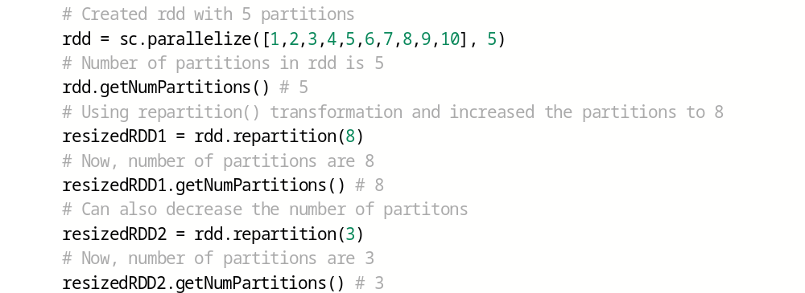

repartitionAndSortWithinPartitions(numPartitions, [partitionFunc, ascending, keyfunc]):
Repartition the RDD according to the given partitioner and, within each resulting partition, sort records by their keys.
It works only on Key-Value pair RDD.
Example:
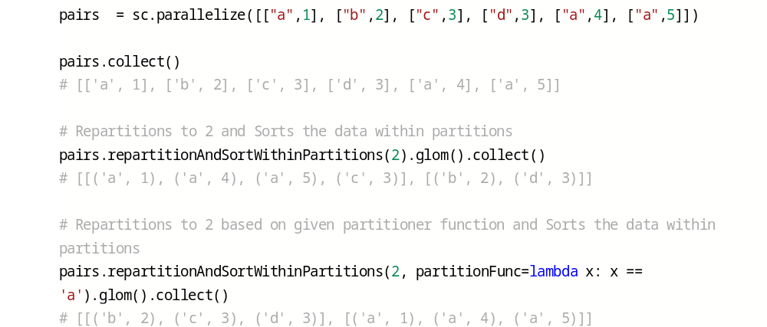

Custom Partitioning:
- Custom partitioners are available only for RDDs.
- Sole goal of custom partitioning is to even out the distribution of your data across the cluster so that you can work around problems like data skew.
- To apply custom partitioning on Structured APIs, convert DataFrame/DataSet to RDD, apply custom partitioner on RDD and then convert back RDD to DataFrame/DataSet.

To perform custom partitioning, need to implement your own paritioner function and use it in partitionBy() method.

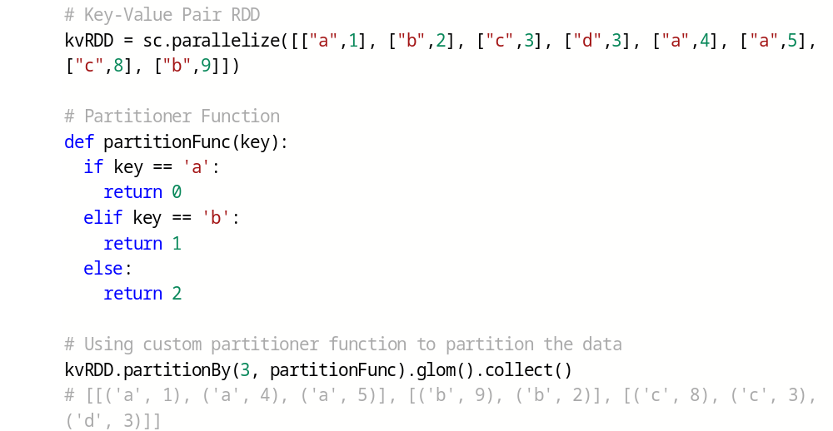
In above example, data which has key as 'a' went to partition-0, which has key as 'b' went to partition-1 and others went to partition-2.

